GNU Octave, version 3.8.2
Copyright (C) 2014 John W. Eaton and others.
This is free software; see the source code for copying conditions.
There is ABSOLUTELY NO WARRANTY; not even for MERCHANTABILITY or
FITNESS FOR A PARTICULAR PURPOSE. For details, type 'warranty'.

Octave was configured for "i586-pc-linux-gnu".

Additional information about Octave is available at http://www.octave.org.

Please contribute if you find this software useful.
For more information, visit http://www.octave.org/get-involved.html

Read http://www.octave.org/bugs.html to learn how to submit bug reports.
For information about changes from previous versions, type 'news'.

a = 1.000000
l = 1.000000
T = 0.080000

ε =
1.0000e-10

n = 80
k = 32
hx = 0.012500
ht = 0.002500

Начальное возмущение =
0.25 * sin(pi * x)

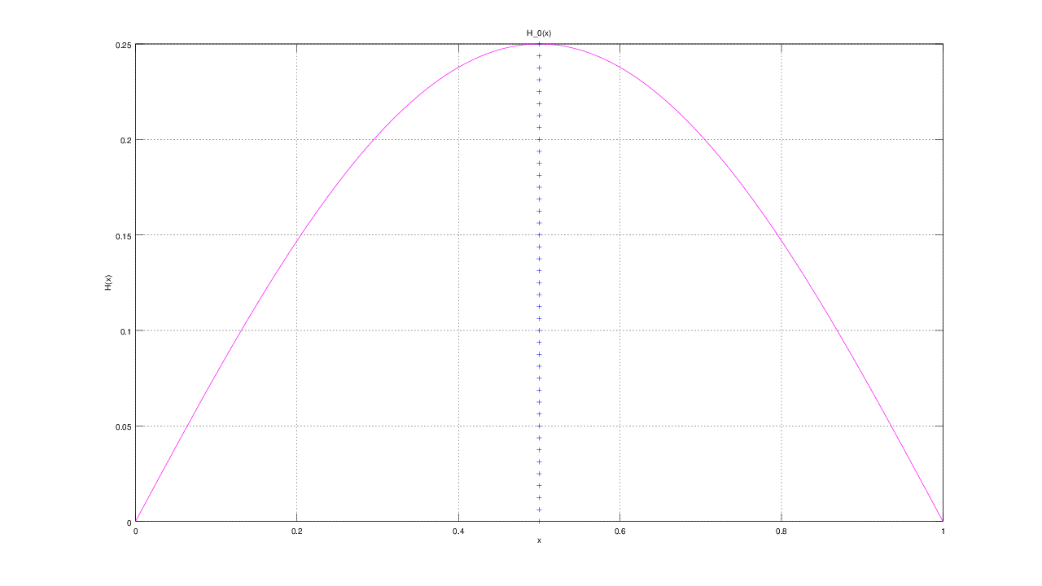

f(x, t)

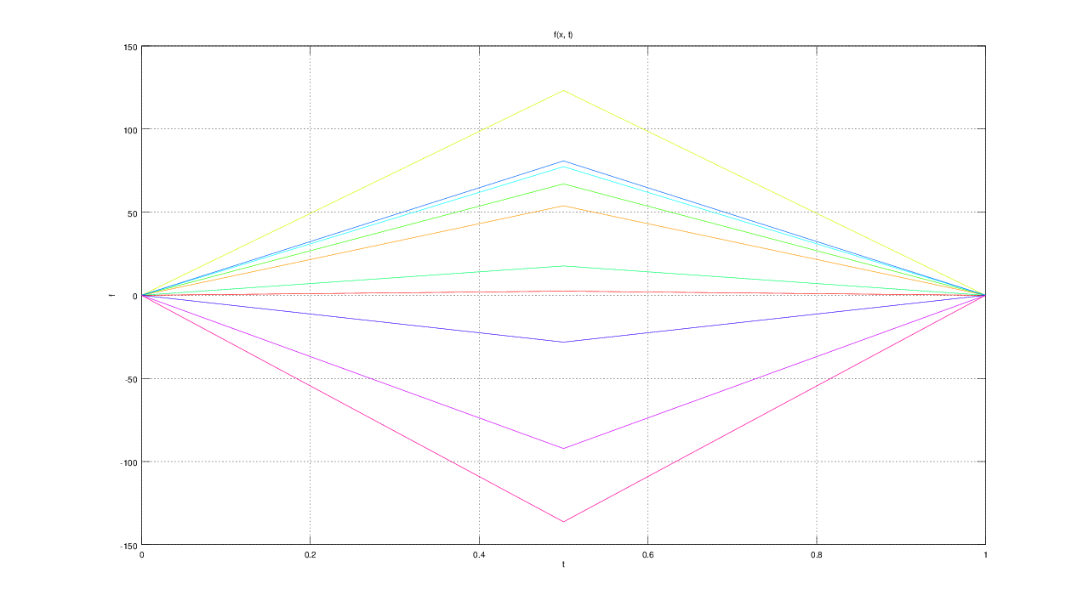

Всего демпферов: 1

Демпфер # 1

x_1 = 0.500000

Верхнее предельное значение w_1(t) =
NaN

Нижнее предельное значение w_1(t) =
NaN

Управляющая функция w_1(t):
-9.9376
-215.3047
-492.7332
-267.9763
-70.5620
-309.4895
-323.3094
112.6743
368.6876
545.0719
506.9271
78.7342
-168.2066
190.2821
322.0639
-176.4228
-586.7108
-284.7539
118.6413
-70.0530
-496.7566
-343.8716
105.9184
367.2258
514.0291
429.4834
121.2265
213.3421
451.4942
82.4290
-373.7194
-189.0911
-18.7667

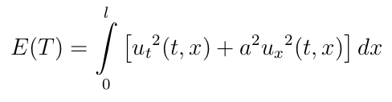

E(T) =
5.7281e-08

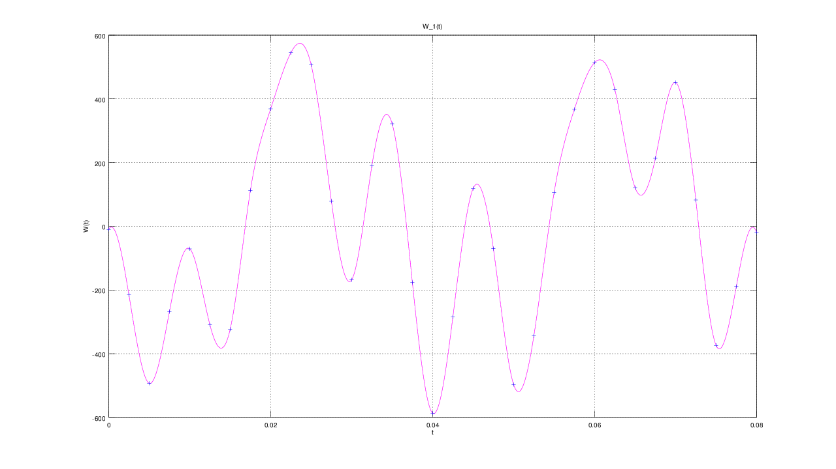

u(x, t)

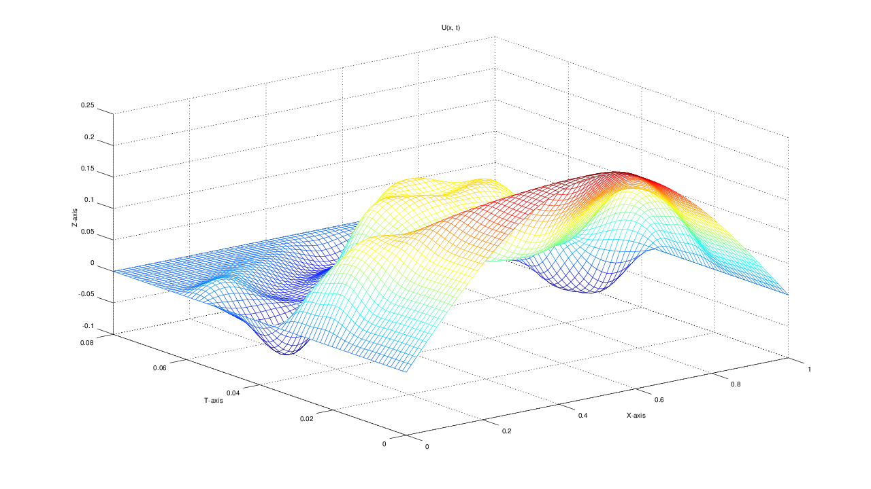
GNU Octave, version 3.8.2
Copyright (C) 2014 John W. Eaton and others.
This is free software; see the source code for copying conditions.
There is ABSOLUTELY NO WARRANTY; not even for MERCHANTABILITY or
FITNESS FOR A PARTICULAR PURPOSE. For details, type 'warranty'.

Octave was configured for "i586-pc-linux-gnu".

Additional information about Octave is available at http://www.octave.org.

Please contribute if you find this software useful.
For more information, visit http://www.octave.org/get-involved.html

Read http://www.octave.org/bugs.html to learn how to submit bug reports.
For information about changes from previous versions, type 'news'.

a = 1.000000
l = 1.000000
T = 0.080000

ε =
1.0000e-10

n = 80
k = 32
hx = 0.012500
ht = 0.002500

Начальное возмущение =
0.25 * sin(pi * x)

Всего демпферов: 1

Демпфер # 1

x_1 = 0.500000

Верхнее предельное значение w_1(t) =
NaN

Нижнее предельное значение w_1(t) =
NaN

Управляющая функция w_1(t):
-10.9046
-159.4070
-291.8945
-130.9609
-43.8010
-117.1356
-127.9488
-16.1669
2.8488
89.3578
139.0053
33.0441
42.5805
185.5037
130.0907
16.0195
-78.8960
-96.3259
-61.5075
-111.1872
-161.0780
-77.2402
-1.0049
51.9923
132.6278
146.9550
105.6134
107.9939
118.8868
104.9573
124.2439
105.2861
101.7274

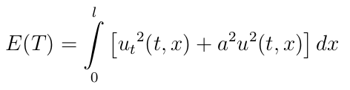
E(T) =
1.4977e-07

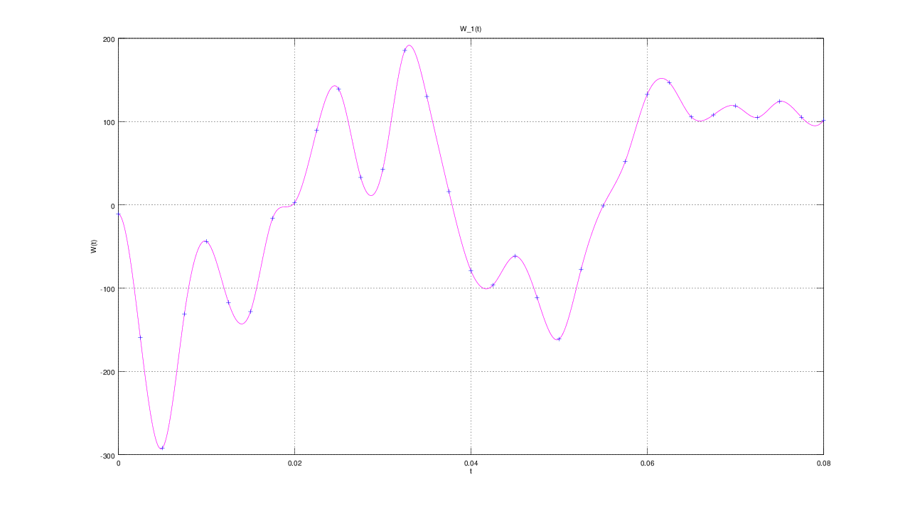

u(x, t)

